**SOP FOR**

1.0**Purpose:** Safe Maintenance of Sinter Cooler for Optimum performance.

2.0 **Scope:** Sinter plant.

3.0 **Responsibility:** Engineer In charge and workmen on the job

4.0 **Procedure:** **Maintenance of Sinter Cooler**

**PPEs to be used**

Helmet, Safety shoes, hand gloves, Ear plug, Dust mask and safety goggle.

**Work No. 1:** Inspection of Pallet wheel, guide wheel and support wheel

**Work No. 2**: Greasing of Rollers

**Work No. 3:** Replacement of Pallet wheel bearing**.**

**Work No. 4:** Inspection of Pallet wheel.

**Work No. 5**: Inspection of Gear box.

**Work No. 6:** Replacement of Gearbox oil.

**Work No. 7:** Lubrication of LS chain coupling

**Work No. 8:** Replacement of Pallet wheel.

**Work No. 9:** Replacement of Guide wheel.

**Work No. 10:** Replacement of Support Wheel.

**Work No. 11:** Replacement of side skirting (outer).

**Work No. 12:** Tightening of hinge bolts.

**Work No. 13:** Inspection of deep rail

**Work No. 14:** Replacement of side skirting (inner**)**

**Work No. 15:** Replacement of Primary Gearbox

**Work No. 16:** Replacement of Secondary Gearbox

**Work No. 17:** SOP to overcome Sinter Cooler Slipping on friction roller

**Aspect - impact**

Dust Generation, Resource Depletion

Scrap generation, Air pollution, Resource depletion, Environmental hazard

**Hazards identified -**

**Mechanical hazard**

1. Inhaling of dust
2. Fire hazard
3. Fall of material
4. Accident due to improper shutdown
5. Flying of Chips during hammering
6. Failure of sling, chain pulley block, hydraulic jack, improper hooks welding
7. Fall of a person
8. Risk on rotary equipment’s

**Electrical hazard**

Electrical shock in welding

**Procedure: –**

**Work No. 1: Inspection of Pallet wheel, guide wheel and support wheel**

1. visual inspection has to be carried out by standing away from wheels during operation
2. Observe for the following points while cooler is running keeping safe distance from the roller or all other rotating parts.
   * + - Abnormal sound from various rollers i.e., pallet wheel, guide wheel and support wheel.
       - Gap if any between support rollers and the guide track.
       - Any scratches on the track or wheel.
       - Smooth operation of the pallet over discharging portion of the rail.
       - Any jerk or unbalancing of pallets over complete rotation.

**Work No. 2: Inspection of Cooler Pallet grate bar**

1. Empty cooler pallet which is to be inspected.
2. Position the cooler pallet at suitable location for inspection.
3. Take shutdown for Sinter cooler from Electrical Department with LOTO.
4. If more than one worker is relying on the protection of an isolation, then all workers should apply their own locks in master lock out box.
5. Press local push emergency button of the cooler.
6. If required replace damaged/worn out plate.
7. If found ok clear electrical shut down.
8. Hand over sinter cooler ~~for~~ to operation dept.

**Work No. 3: Greasing of Rollers**

1. Take shutdown for Sinter cooler from Electrical Department with LOTO.
2. If more than one worker is relying on the protection of an isolation, then all workers should apply their own locks in master lock out box
3. Press local push emergency button of the Sinter machine.
4. Clean the grease nipple carefully, check nipple for any damage, if required replace the nipple
5. Fix grease gun at outer cover grease point.
6. ~~Put~~ Fill adequate amount of grease with the help of gun.
7. Remove the grease gun from grease nipple.
8. Remove all the tools from place and clean working area.
9. Clear electrical shutdown.
10. Hand over sinter cooler ~~for~~ to operation dept.

**Work No. 4: Replacement of Pallet wheel bearing.**

1. ~~Empty cooler before taking shut down.~~

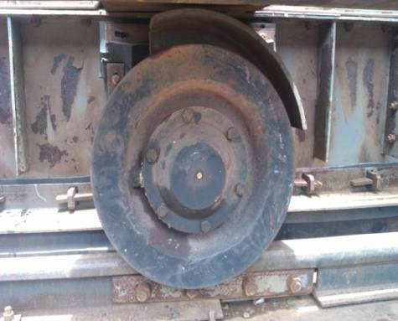

1. Place the pallet car at suitable position. ~~(dumping zone)~~
2. Take shutdown for Sinter cooler from Electrical Department with LOTO.
3. If more than one worker is relying on the protection of an isolation, then all workers should apply their own locks in master lock out box
4. Press local push emergency button of the cooler.
5. ~~Make sure wheel which is to be replaced is brought to cooler discharging area.~~
6. ~~With the help of chain block lift wheel axle to have enough clearance between wheel and rail.~~
7. ~~Provide suitable work support to avoid fall of wheel~~
8. Place Hydraulic Jack (30T Capacity) behind wheel under axle and lift the wheel slowly just to have enough clearance between wheel and rail so that wheel and bearing can be removed easily. Ensure enough support is provided under wheel incase jack failure.
9. Check clearance of bearing using filler gauge. If clearance is found more than 1.5mm, or there is dug in wheel, then bearing to be replaced immediately.
10. Unlock/Open triangular locking plate after opening wheel cover, remove bolts and remove wheel and bearing from wheel shaft using puller.
11. Provide suitable work support to avoid fall of wheel.
12. ~~Remove the roller and dismantle the bearing from the shaft using puller.~~
13. Clean the shaft & check dimensions for wear out before replacing bearing.
14. Fix end cover first.
15. Fix new bearing in roller/wheel.
16. Fix and lock locking plate and all bolts properly.
17. Fill EP2 grade grease using grease gun & seal it properly.
18. ~~Fix end cover.~~
19. Clean the work area.
20. Clear shut down and take no load trail. Check for any abnormalities.
21. If entire cooler is not emptied, ensure LS1 to screen circuit is in operation before starting cooler.
22. If found satisfactory hand over sinter cooler ~~for~~ to operation dept.

**Work No. 5: Inspection of Gear box.**

1. visual inspection must be carried out by standing away during operation
2. Keep safe distance from gearbox and motor.
3. Consider following points for gearbox inspection.

* Any abnormal sound.
* High vibrations.
* Low Oil level.
* Coupling abnormalities.

1. If any of the above observation deviates from the normal, consider rectifying it by taking due and electrical shutdown.

**Work No. 6: Replacement of Gear oil**

1. Take shutdown for Sinter cooler from Electrical Department with LOTO.
2. If more than one worker is relying on the protection of an isolation, then all workers should apply their own locks in master lock out box
3. Press local push emergency button of the cooler.
4. Drain out oil from gearbox in a container.
5. Take oil sample if required.
6. Flush out the gearbox for proper cleaning.
7. Clean the breather.
8. Pour the recommended grade oil to required level.
9. Ensure all guards in place.
10. Clear the work permit as well as electrical shut down.
11. Hand over sinter cooler for to operation dept.

**Work No.7: Lubrication of LS chain coupling**

1. Take shutdown for Sinter cooler from Electrical Department with LOTO.
2. If more than one worker is relying on the protection of an isolation, then all workers should apply their own locks in master lock out box
3. Press local push emergency button of the cooler.
4. Remove coupling cover.
5. Take out old grease from the coupling.
6. Inspect chain condition.
7. Apply grease of required amount.
8. Fix back coupling guard.
9. Clear the work permit as well as electrical shut down and observe the operation for healthiness.
10. Hand over sinter cooler ~~for~~ to operation dept.

**Work No. 8: Replacement of Pallet wheel**

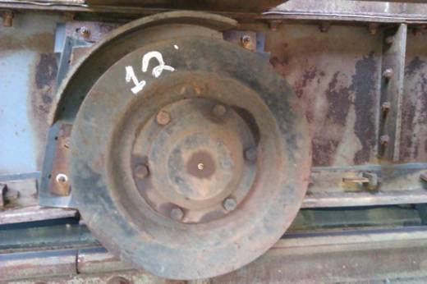

1. Take shutdown for Sinter cooler from Electrical Department with LOTO.
2. If more than one worker is relying on the protection of an isolation, then all workers should apply their own locks in master lock out box
3. Press local push emergency button of the cooler.
4. ~~Make sure wheel which is to be replaced is brought to cooler discharging area.~~
5. ~~With the help of chain block lift wheel axle to have enough clearance between wheel and rail.~~
6. ~~Provide suitable work support to avoid fall of wheel~~
7. Place Hydraulic Jack (30T Capacity) behind wheel under axle and lift the wheel slowly just to have enough clearance between wheel and rail so that wheel and bearing can be removed easily. Ensure enough support is provided under wheel incase jack failure.
8. Unlock/Open triangular locking plate after opening wheel cover, remove bolts and remove wheel and bearing from wheel shaft using puller.
9. ~~Fix puller and remove the wheel.~~
10. Replace it with new wheel.
11. Fix locking plate and top cover with bolts.
12. Release hydraulic jack ~~chain block~~ and ensure proper placement of axle on rail track.
13. Remove all tools from working area.
14. Clear electrical shut down and take no load trail. Check for any abnormalities.
15. If found satisfactory, clear work permit.
16. Hand over sinter cooler ~~for~~ to operation dept.

**Work No. 9: Replacement of Guide wheel.**

1. Take shutdown for Sinter cooler from Electrical Department with LOTO.
2. If more than one worker is relying on the protection of an isolation, then all workers should apply their own locks in master lock out box
3. Press local push emergency button of the cooler.
4. Remove cover of guide wheel.
5. Remove all bolts of guide wheel frame from guide track and make wheel free.
6. Replace this wheel with new guide wheel.
7. Fasten all nut and bolts to required amount.
8. Place guard over the guide wheel.

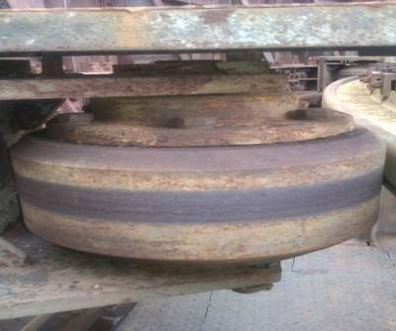 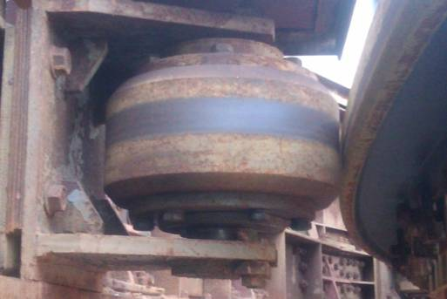

Guide wheel

1. Remove all tools from the working area.
2. Clear electrical shut down and take no load trail. Check for any abnormalities.
3. If found satisfactory hand over sinter cooler ~~for~~ to operation dept.

**Work No. 10: Replacement of Supporting Wheel**

1. Take shutdown for Sinter cooler from Electrical Department with LOTO.
2. Reduce tension of the spring which holds two support wheels.
3. Remove bolts holding support wheel frame.

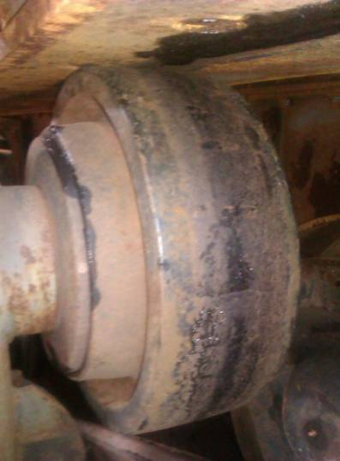

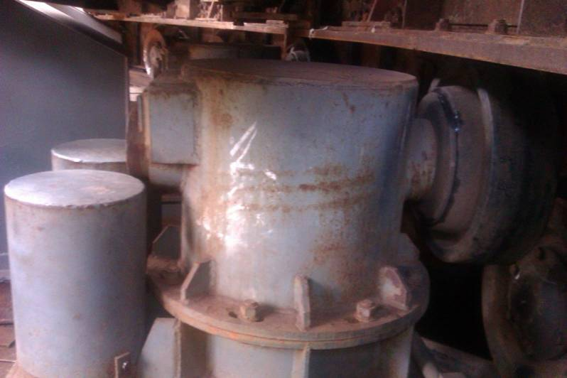

1. Replace old wheel with new one and fasten all nut and bolts.
2. Tight the springs until two wheels hold the guide beam.
3. Remove all tools from the working area.
4. Clear electrical shut down and take no load trail. Check for any abnormalities.
5. Hand over sinter cooler ~~for~~ to operation dept.

**Work No. 11:** **Replacement of side skirting (outer)**

1. Take shutdown for Sinter cooler & chill fans from Electrical Department with LOTO.
2. If more than one worker is relying on the protection of an isolation, then all workers should apply their own locks in master lock out box
3. Press local push emergency button of ~~the~~ all equipment.
4. Release skirt rubber clamp by removing wedges
5. Remove old skirt rubber; replace new skirt rubber with proper position.
6. Fix clamps with help of wedges. Remove all tools from working area.
7. Clear electrical shut down.
8. Hand over sinter cooler ~~for~~ to operation dept.

**Work No. 12: Tightening of hinge bolts**

1. Ensure all sinter pallet cars are emptied.
2. Take shutdown for Sinter cooler, sinter machine, SRC & chill fans (3nos) from Electrical Department with LOTO.
3. If more than one worker is relying on the protection of an isolation, then all workers should apply their own locks in master lock out box
4. Press local push emergency button of the Equipment.
5. Open hinge cover to facilitate hinge bolt access (as shown in below fig.)

Hinge cover & bolt



1. Check & tighten hinge bolts. (With hammering spanner 36mm)
2. Fix back hinge cover plate.
3. Check all hinge bolts for tightness.
4. Ensure all hinge cover plates in place.
5. Clear the electrical shut down.
6. Hand over sinter cooler ~~for~~ to operation dept.

**Work No. 13: Inspection of deep rail**

1. Ensure all sinter pallet cars emptied.
2. Take shutdown for Sinter cooler, Tail ID Fan, LS1 & chill fans (3nos) from Electrical Department with LOTO.
3. If more than one worker is relying on the protection of an isolation, then all workers should apply their own locks in master lock out box
4. Press local push emergency button of the Equipment.
5. Open inspection door near Support roller on Cooler platform.
6. Carry torchlight /24V hand lamp for inspection of deep rail.
7. Use full harness safety belt.
8. Check deep rail for any crack, damage & wear-tear.
9. After checking come out from chute (minimum 2 persons should be involved in this activity)
10. Close inspection door. Clear the electrical shut down.
11. Hand over sinter cooler ~~for~~ to operation dept.

**Work No. 14. Replacement of side skirting (inner)**

1. This is a confined space working and necessary control measures and deliberations must be in place before taking up this job.
2. Take work permit from production department
3. Take electrical shutdown of sinter cooler, chill fans (3nos).
4. If more than one worker is relying on the protection of an isolation, then all workers should apply their own locks in master lock out box
5. Press local push emergency button of the Equipment.
6. Ensure sufficient illumination or arrange necessary lighting arrangement (torch/24v hand lamp
7. Ensure that the Sinter Cooler pallet cars are empty under which job of sealing is to be carried out.
8. Open the duct entrance manholes (all 3 no’s)
9. Ensure that the inside duct temperature is in a comfortable range.
10. Ensure that the hoppers are empty of any sinter material.
11. Release skirt rubber clamp by removing bolts. Remove old skirt rubber; replace new skirt rubber with proper position.
12. Fix clamps with help of bolts. Remove all tools from working area.
13. Close all the 3 duct entrance manholes.
14. Clear electrical shut down.
15. Clear work permit.
16. Hand over sinter cooler ~~for~~ to operation dept.

**Work No. 15: Replacement of Primary Gearbox**

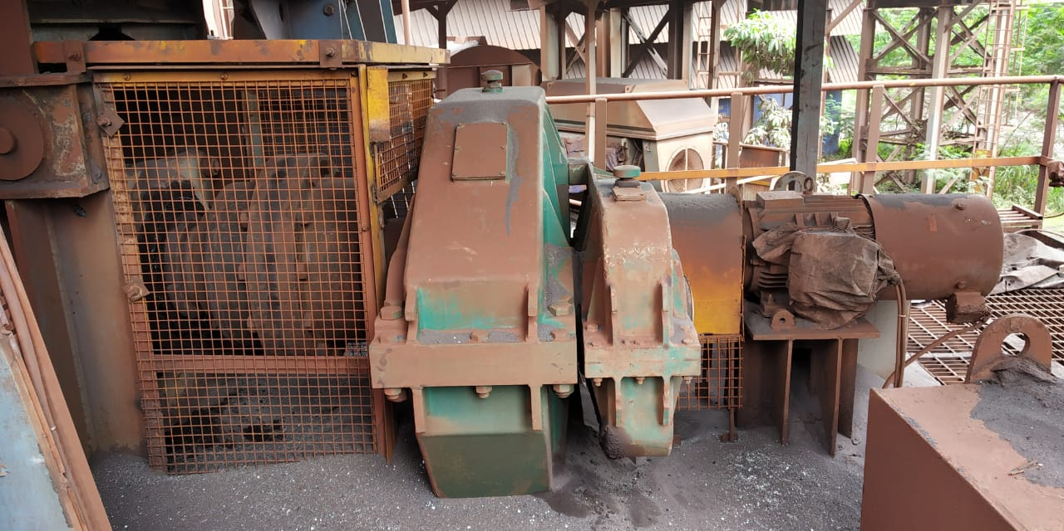

1. Take shutdown for Sinter cooler from Electrical Department with LOTO.
2. If more than one worker is relying on the protection of an isolation, then all workers should apply their own locks in master lock out box
3. Press local push emergency button of the cooler.
4. Position 80T Crane beside H1 Conveyor (incase LS#2 side GB to be replaced) as there is not enough space for Hydra movement or for positioning of 30T Crane.
5. Remove all Guards.
6. Inform electrical dept to disconnect motor cable
7. Remove roof sheeting of Gearbox shed
8. Decouple motor from secondary gearbox as it is coupled using chain sprocket
9. Remove or decouple secondary Gearbox from Primary Gearbox (To be done incase only Primary GB to be replaced. No need to separate Gearboxes if both to be replaced at a time)
10. Decouple Primary Gearbox from Cooler by removing bolts of Gear teeth pinion hub.
11. Remove foundation bolts of Primary Gearbox.
12. Take out Primary Gearbox using crane with appropriate and certified lifting tools.
13. Position new gearbox on the position.
14. Couple New Gearbox to Cooler by fixing bolts of pinion hub and fix foundation bolts of Gearbox too.
15. Check alignment and fix or couple Secondary Gearbox to Primary Gearbox.
16. Couple motor with Secondary gearbox.
17. Ask Electrical dept to connect motor cables.
18. Place and fix the removed roof sheet of Gear Box shed.
19. Ensure all guards in place.
20. Clear area
21. Clear the work permit as well as electrical shut down.
22. Take trial and ensure vibration readings are in normal parameter
23. Hand over sinter cooler to operation dept.

**Work No. 16: Replacement of Secondary Gearbox**

1. Take shutdown for Sinter cooler from Electrical Department with LOTO.
2. If more than one worker is relying on the protection of an isolation, then all workers should apply their own locks in master lock out box
3. Press local push emergency button of the cooler.
4. TMC to be positioned before starting of job to remove and replace Secondary Gearbox
5. Remove all Guards.
6. Inform electrical dept to disconnect motor cable
7. Decouple motor from secondary gearbox as it is coupled using chain sprocket
8. Remove or decouple secondary Gearbox from Primary Gearbox.
9. Take out Secondary Gearbox using TMC with appropriate and certified lifting tools.
10. Couple New Secondary Gearbox to Primary Gearbox again using TMC or certified lifting tools.
11. Couple motor with Secondary gearbox and check alignment.
12. Ask Electrical dept to connect motor cables.
13. Ensure all guards in place.
14. Clear area
15. Clear the work permit as well as electrical shut down.
16. Take trial and hand over sinter cooler to operation department.

**Work No. 17: SOP to overcome Sinter Cooler Slipping on friction roller**

When this condition occurs, it means Sinter Cooler Friction Roller slips on track resulting in no movement of Sinter Cooler. Pictures are attached below: 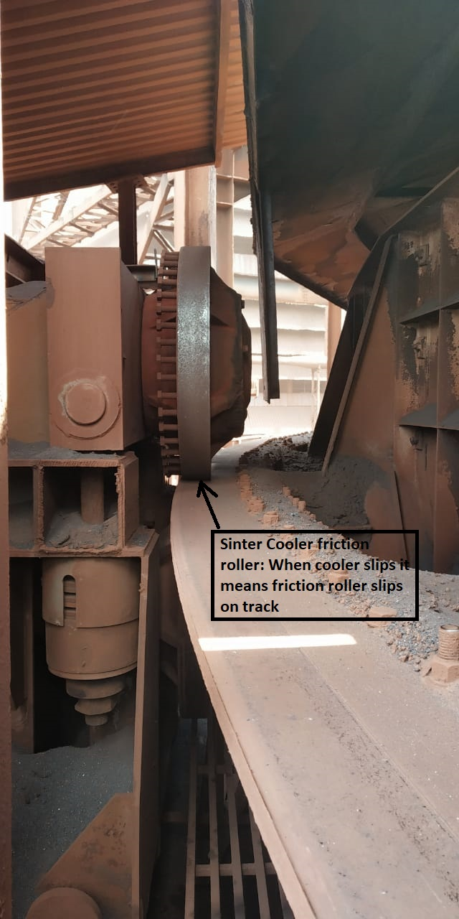

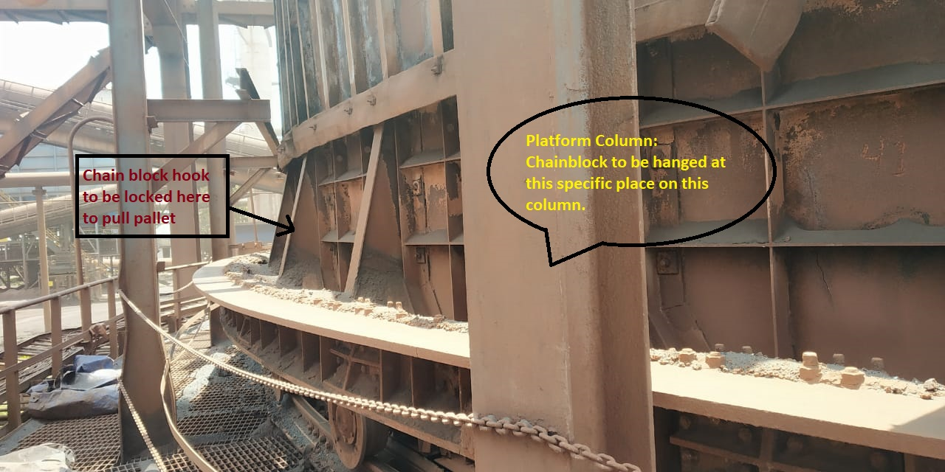

To overcome this situation below SOP to be followed.

1. Take shutdown for Sinter cooler from Electrical Department with LOTO.
2. If more than one worker is relying on the protection of an isolation, then all workers should apply their own locks in master lock out box
3. Press local push emergency button of the cooler.
4. As can be seen in above attached pictures, after taking Sinter Cooler shutdown chain block (3T/5T) as per requirement to be hanged to platform column and hook of chain block to be locked to a pallet car.
5. Now release shutdown, and start cooler. Start pulling chain block so that pallet car is pulled towards friction roller thus attaining back its friction.
6. Same arrangement to be done to opposite side of friction roller to complete activity at faster pace. Please note that pulling must be done in one direction only and not in opposite direction.
7. Once friction is attained, release chain blocks and remove hooks from pallet cars by stopping cooler.
8. Clear area
9. Clear the work permit as well as electrical shut down.
10. Take trial and hand over sinter cooler to operation department.

Note: -

* Always ensure circuit after Sinter Cooler (C#4, C#3, Product Screens, LS#3, LS#2, LS#1) is in running state before starting Sinter Cooler after maintenance or for Sinter Cooler manual rotation.
* If any time during s/d if there is any need of starting the Sinter Cooler in manual mode, ensure that Sinter Cooler pallet cars are completely empty of Sinter, if not then do not start Cooler at all as it will result in discharge chute jamming and belt overloading.
* And if Cooler pallet cars are empty then take permission from SS and wait for designated operator from Operation department to start Sinter Cooler.
* Sinter Cooler to be operated by authorized personnel only.

**Reference: -**

**Amendement Record**

|  |  |  |  |
| --- | --- | --- | --- |
| **Date** | **Manual Section Ref. & Para** | **Brief details of Revision** | **New Rev.** |
|  |  |  |  |
|  |  |  |  |
|  |  |  |  |

|  |  |  |
| --- | --- | --- |
| **Prepared By:**  Associate Manager- Sinter Plant Mechanical | **Reviewed & Issued By:**  Management Representative | **Approved By:**  **Manager- Mechanical PID2** |
| **Signature:** | **Signature:** | **Signature:** |
| **Review Date: 30.07.2022** | **Review Date: 30.07.2022** | **Review Date: 30.07.2022** |